

20|21 SEASON

**COPPELIA**

**Ballet in 3 acts**

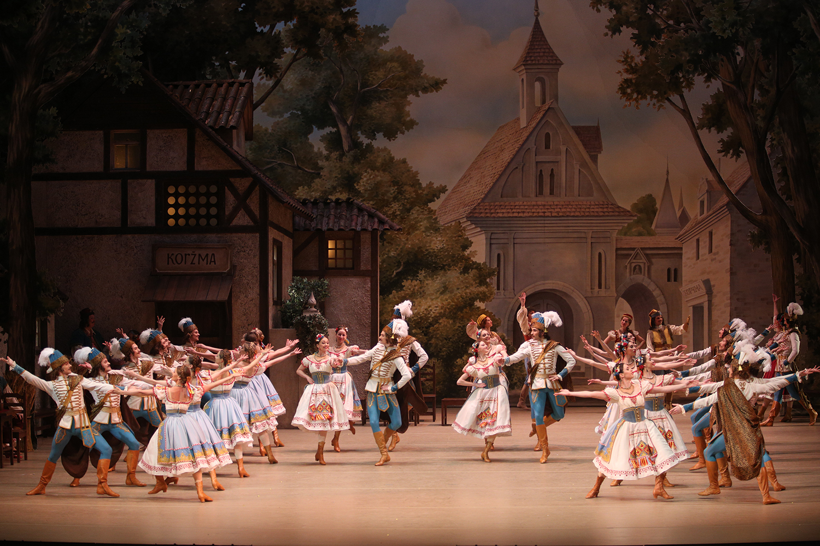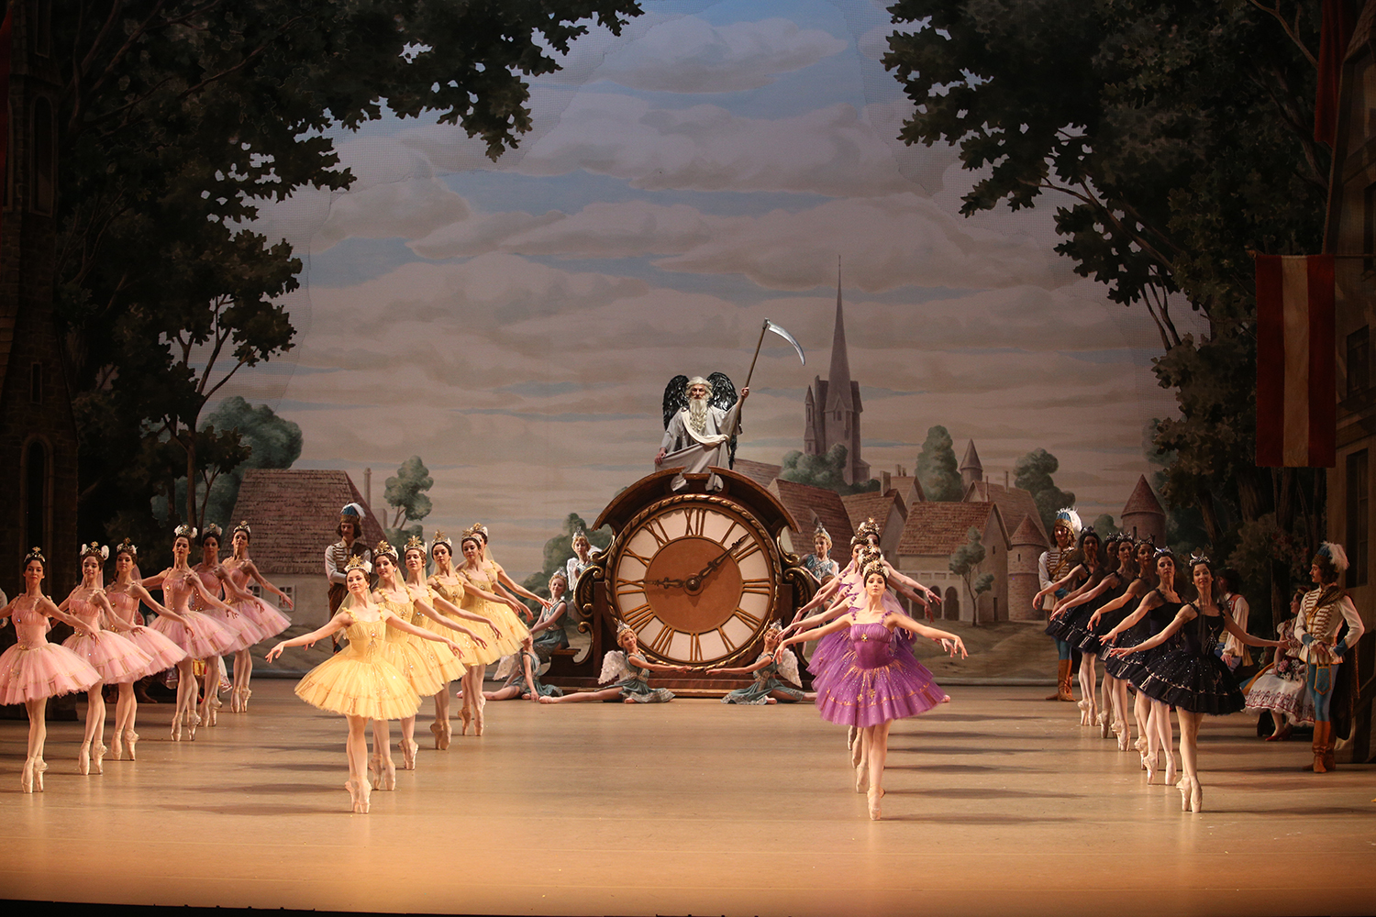

**ACT I**

Every morning, Coppélia, daughter of Coppélius, sits reading outside the window of her balcony. Swanilda suspects her fiancé, Frantz, to be one of her admirers. She superstitiously asks a straw of wheat if Frantz loves her but the answer seems to be no.  Swanilda notices that Coppélius has dropped a key. With her friends, she decides to visit his mysterious house…

**ACT II**

In Coppélius’ house, Swanilda salutes Coppélia but the strange girl remains motionless: she is a life-sized doll! Suddenly Coppélius bursts into the room and Swanilda hides behind the curtains. A few minutes later, Coppélius seizes Frantz who enters the house using a ladder. He implores the old man and confesses his love for Coppélia. Coppélius believes he can draw energy from Frantz to bring Coppélia to life…

**ACT III**

Frantz knows a joke has been played on him and thinks nothing more of Coppélia. He’s to be married to Swanilda before the Lord of the manor. At once there is a stir among the crowd. Coppélius comes to demand justice; they have ridiculed him and have broken everything in his house. Who is going to pay? The Lord of the manor throws a purse to him and gives the signal for the festivities to begin.

CAPTURED LIVE IN MOSCOW

**SCHEDULE**

12 min Introduction

34 min Act I

15 min Intermission with interview

26 min Act II

6 min Intermission

30 min Act III

5 min Bows and credits

MUSIC **LÉO DELIBES**

CHOREOGRAPHY **SERGEY VIKHAREV**

MUSICAL DIRECTION **PAVEL SOROKIN**

# HOST KATERINA NOVIKOVA

# DIRECTED BY ISABELLE JULIEN

**CAST**

SWANILDA **MARGARITA SHRAYNER**

FRANTZ **ARTEM OVCHARENKO**

COPPELIUS **ALEXEI LOPAREVICH**

FRIENDS TO SWANILDA **DARIA BOCHKOVA, ANTONINA CHAPKINA, ANASTASIA DENISOVA, ELIZAVETA KRUTELEVA, DARIA LOVTSOVA, SVETLANA PAVLOVA, ELEONORA SEVENARD, YULIA SKVORTSOVA**

AND **THE BOLSHOI CORPS DE BALLET**

Captured live in Moscow on Sunday, June 10, 2018.

© Elena Festisova / Natalia Voronova





**#Coppelia**  BolshoiBalletintheUS @BolshoiBalletUS @bolshoiballet.us

FathomEvents @FathomEvents @fathomevents

**BOLSHOIBALLETINCINEMA.COM**

