

20|21 SEASON

**THE SLEEPING BEAUTY**

**Ballet in 2 acts**

**ACT I**

After not being invited to Princess Aurora’s christening, the evil fairy Carabosse casts a curse on the child: she will die at 16 from pricking her finger with a knitting spindle. Fortunately, the Lilac Fairy has the power to mitigate the spell. Instead of dying, Aurora will fall into a deep slumber from which only the kiss of a prince could wake her…

**CAPTURED LIVE IN MOSCOW**

**SCHEDULE**

12 min Introduction

59 min Act I

9 min Intermission with interview

67 min Act II

5 min Bows and credits

MUSIC **PYOTR ILYICH TCHAIKOVSKY**

CHOREOGRAPHY **YURI GRIGOROVICH**

MUSICAL DIRECTION **PAVEL SOROKIN**

# HOST KATERINA NOVIKOVA

# DIRECTED BY VINCENT BATAILLON

**CAST**

PRINCESS AURORA **OLGA SMIRNOVA**

PRINCE DÉSIRÉ **SEMYON CHUDIN**

THE LILAC FAIRY **YULIA STEPANOVA**

THE EVIL FAIRY CARABOSSE **ALEXEY LOPAREVICH**

PRINCESS FLORINE **ANASTASIA DENISOVA**

CATABULETTE **VITALY BIKTIMIROV**

BLUEBIRD **ARTEMY BELYAKOV**

AND **THE BOLSHOI CORPS DE BALLET**

Captured live in Moscow on January 22, 2017

Captured live in Moscow on Sunday, December 23, 2018.

**ACT II**

100 years have passed. Prince Désiré has yet to find his princess. One evening, the Lilac Fairy summons a vision of Aurora and the Prince sees his beloved maiden in the enchanting Princess. He asks the Lilac Fairy to take him to her and awakens her with a kiss.

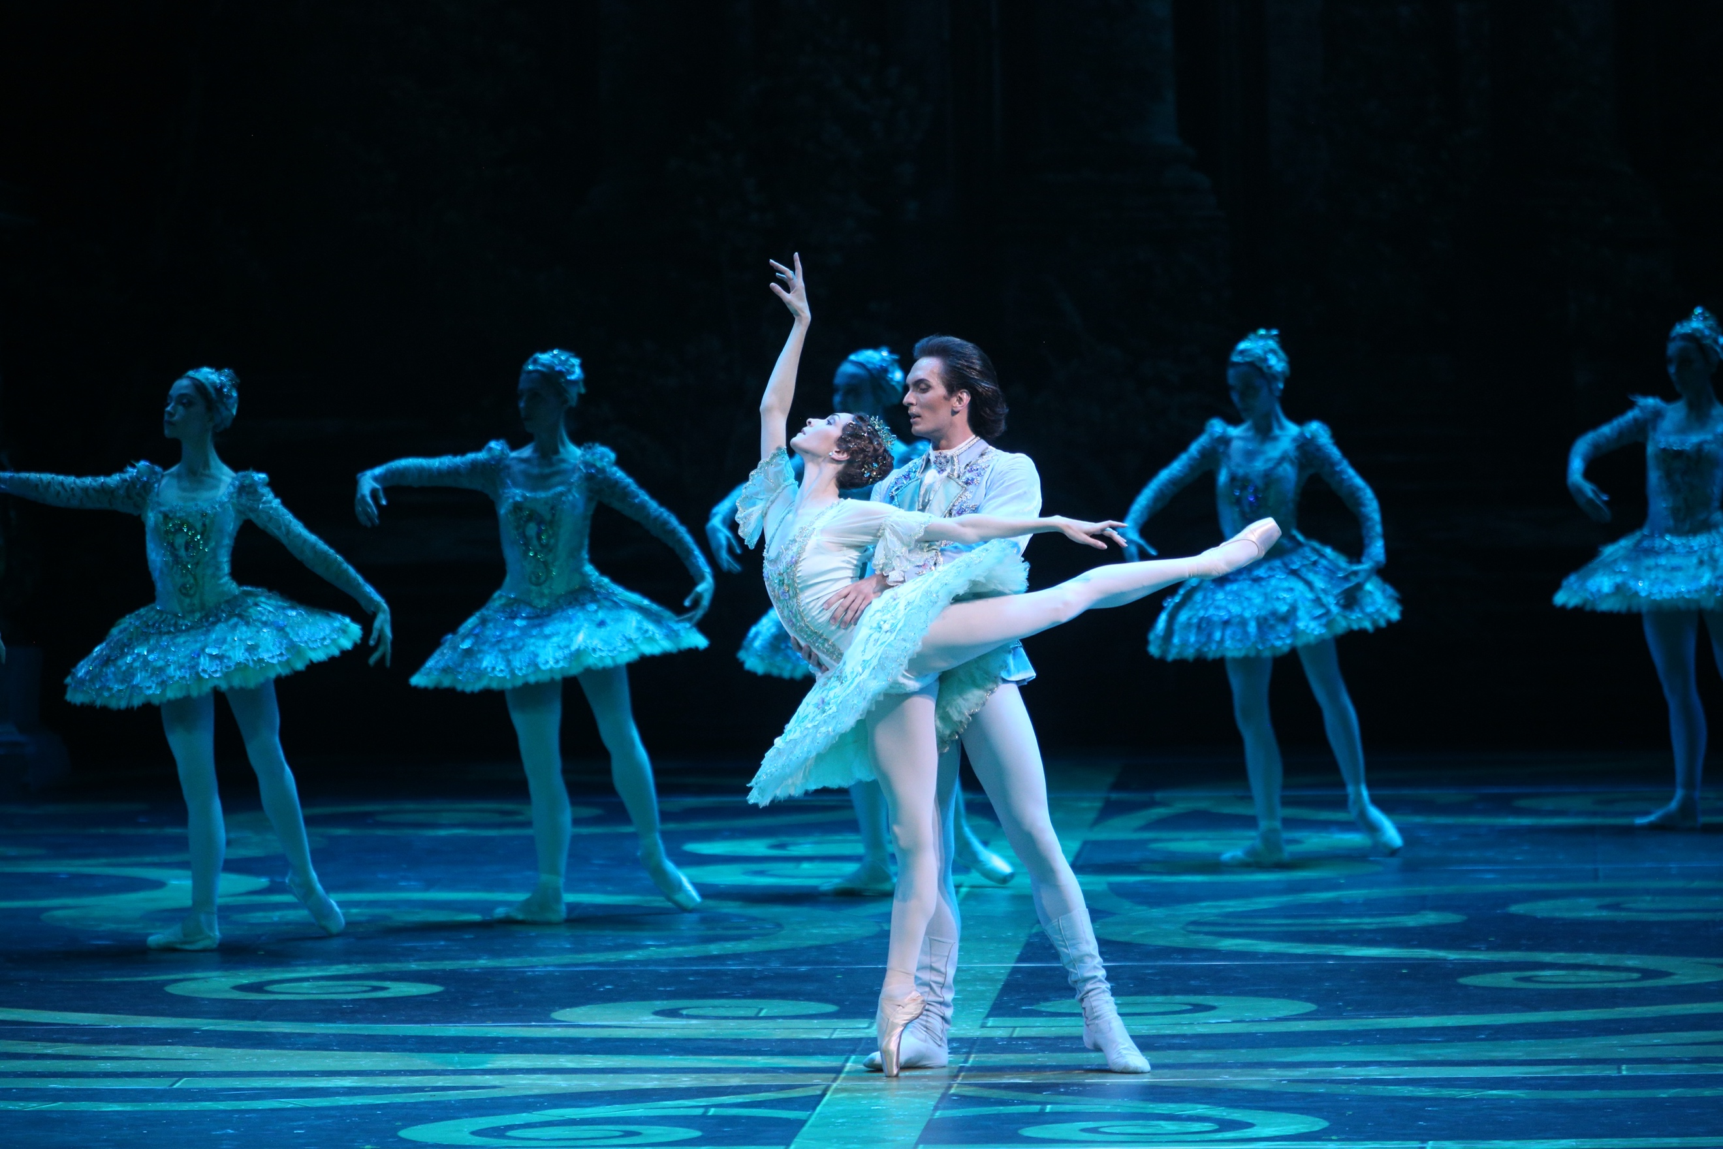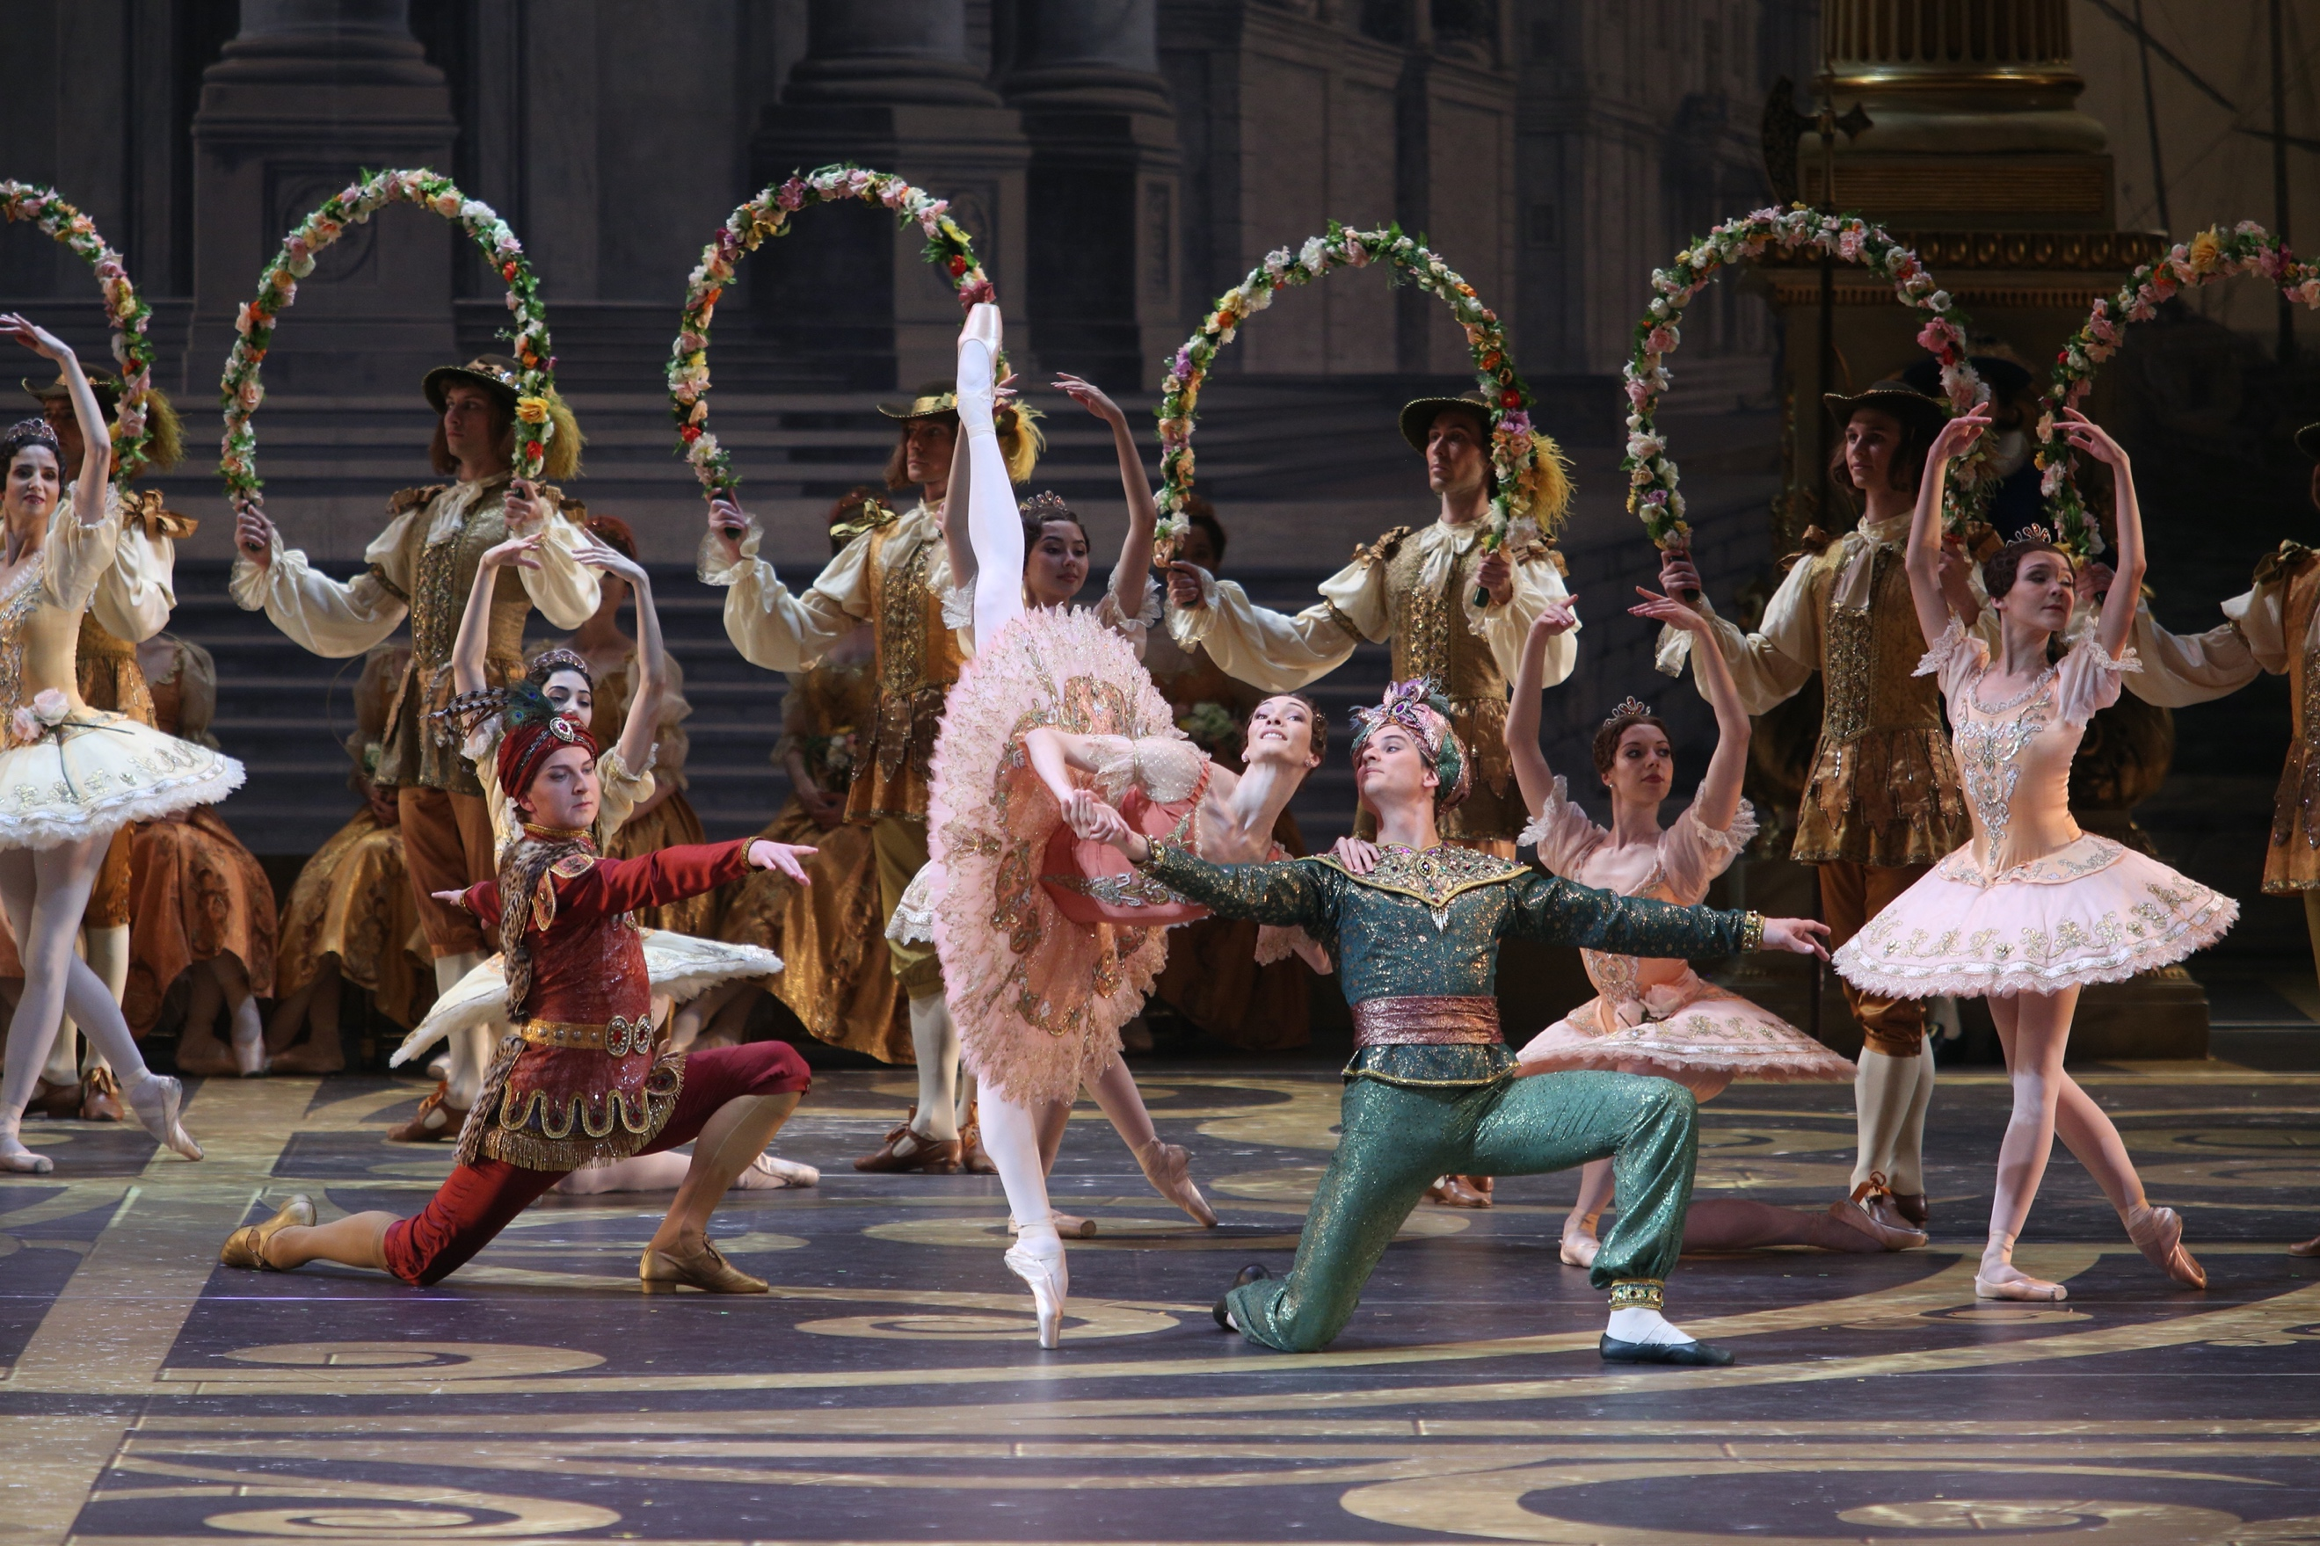

© Elena Festisova





**#TheSleepingBeauty** BolshoiBalletintheUS @BolshoiBalletUS @bolshoiballet.us

FathomEvents @FathomEvents @fathomevents

**BOLSHOIBALLETINCINEMA.COM**

