


FOR IMMEDIATE RELEASE
Tickets Now On Sale for Sony Pictures Classics and
Fathom Entertainment’s Live Filmed Version of Tony-Winning Merrily We Roll Along Directed By Maria Friedman, Starring Daniel Radcliffe, Jonathan Groff & Lindsay Mendez
New Trailer and Poster Ahead of Film’s Highly Anticipated Global Theatrical Release on December 5
Watch Trailer: HERE
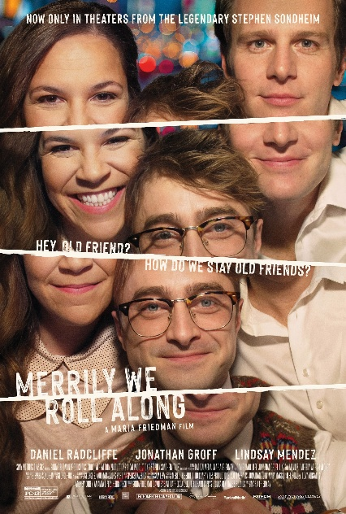

Download Poster: HERE
Photo Credit: Sony Pictures Classics
NEW YORK and DENVER - October 16, 2025 – Sony Pictures Classics announced today that tickets are now on sale for Merrily We Roll Along, the live filmed version of the smash four-time Tony Award-winning musical performance, directed by Maria Friedman. The film will open in theaters worldwide beginning on December 5, 2025, and will be released in collaboration with Fathom Entertainment, the leading specialty distributor of content to theatrical partners worldwide.
In advance of the highly anticipated immersive film, Sony Pictures Classics has debuted the official trailer HERE, giving audiences an early glimpse at the brilliant and groundbreaking vision of Friedman and showcasing the incredible performances by Tony Award winners Daniel Radcliffe, Jonathan Groff, and Lindsay Mendez, alongside Krystal Joy Brown, Katie Rose Clark and Reg Rogers.
Tickets for Merrily We Roll Along are available now at Fathom Entertainment and participating theatre box offices (theatre locations are subject to change). For more information, visit Fathom Entertainment.
Spanning three decades, Merrily We Roll Along charts the turbulent relationship between composer Franklin Shepard and his two lifelong friends — writer Mary and lyricist & playwright Charley. Originally produced on Broadway in 1981, then becoming an inventive cult-classic ahead of its time, the musical features some of Stephen Sondheim’s most celebrated and personal songs.
The 2023-2024 Broadway production, directed by Friedman, redefined the show for a new era, bringing Stephen Sondheim’s intricate score and George Furth’s book to vivid life with extraordinary depth and clarity. Merrily We Roll Along shattered the Hudson Theatre’s house record on Broadway, solidifying its place as a landmark event in Broadway history. The critically acclaimed production won the 2024 Tony Awards for Best Revival of a Musical, Best Performance by an Actor in a Leading Role in a Musical, Best Performance by an Actor in a Featured Role in a Musical and Best Orchestrations. Additionally, in London, Merrily We Roll Along garnered the most five-star reviews in West-End history, with Friedman’s production also winning the Olivier Award for Best Musical Revival.
Merrily We Roll Along is produced by Sonia Friedman, David Babani, Patrick Catullo, F. Richard Pappas, RadicalMedia’s Jon Kamen, and Dave Sirulnick. Executive Producers include Meredith Bennett, No Guarantees Productions, Scott Abrams, Jonathan Corr, Mary Maggio, Jeff Romley, Tony Yurgaitis, Andrew Cohen, Amanda Lipitz, Henry Tisch alongside Co-executive producer Stephanie P. McClelland. Karla Zambrano and Alec Sash serve as Supervising Producers.
In addition to Merrily We Roll Along, Fathom Entertainment has distributed several past live and live filmed Broadway musical productions to movie theatres, including Waitress: The Musical, Kinky Boots, and Newsies. Fathom also has a longstanding theatrical distribution partnership in the U.S. with The Met for its annual Live in HD opera series.
Merrily We Roll Along is available theatrically from Fathom Entertainment in the United States and will also be distributed by Fathom in Australia/New Zealand, Canada, Ireland, and the UK
About Sony Pictures Classics
Michael Barker and Tom Bernard serve as co-presidents of Sony Pictures Classics—an autonomous division of Sony Pictures Entertainment they founded with Marcie Bloom in January 1992—which distributes, produces, and acquires independent films from around the world. Barker and Bernard have released prestigious films that have won 42 Academy Awards® (38 of those at Sony Pictures Classics) and have garnered 190 Academy Award® nominations (164 at Sony Pictures Classics) including Best Picture nominations for I’M STILL HERE, THE FATHER, CALL ME BY YOUR NAME, WHIPLASH, AMOUR, MIDNIGHT IN PARIS, AN EDUCATION, CAPOTE, HOWARDS END, and CROUCHING TIGER, HIDDEN DRAGON.
About Fathom Entertainment
Fathom Entertainment is the leading global specialty distributor of content to movie theatres. For more than 20 years, Fathom Entertainment has pioneered theatrical distribution of events and special engagements across various genres and formats, including feature films, episodic content, documentaries, concerts, and live events. Fathom consistently ranks among the top 10 theatrical distributors in North America, and distributes content to cinemas worldwide. Fathom Entertainment is owned by AMC Entertainment Inc. (NYSE: AMC), Cinemark Holdings, Inc. (NYSE: CNK), and Regal Cineworld Group (LSE: CINE.L). For more information, visit FathomEntertainment.com.
About Sony Pictures Entertainment
Sony Pictures Entertainment (SPE) is a subsidiary of Tokyo-based Sony Corporation. SPE's global operations encompass motion picture production, acquisition, and distribution; television production, acquisition, and distribution; television networks; digital content creation and distribution; operation of studio facilities; and development of new entertainment products, services. http://www.sonypictures.com/corp/divisions.html.
.
###
Contacts:
Sony Pictures Classics Eric Becker
spc@id-pr.com Fathom Entertainment
ebecker@fathomentertainment.com
(303) 638-3469

