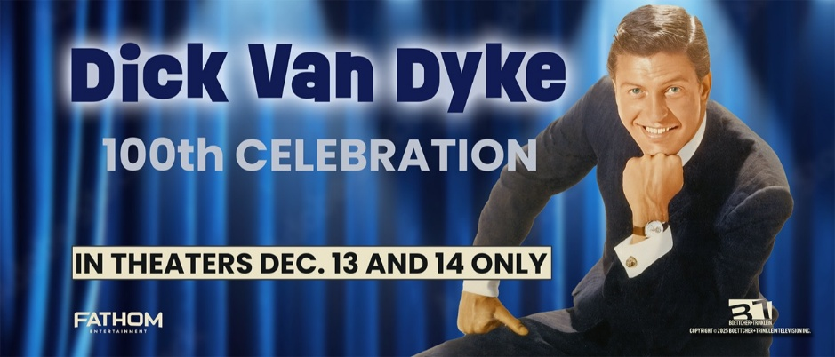
Steve Boettcher and Michael Trinklein
Bios

STEVE BOETTCHER
Executive Producer/Director

Steve Boettcher is a five-time Emmy-winning filmmaker who created the popular PBS series Pioneers of Television. After Pioneers, Boettcher began a series of ambitious documentaries, each featuring a single iconic celebrity. The first, Robin Williams Remembered, was one of PBS’ top-rated shows of the year. That film was followed by Mary Tyler Moore: A Celebration, and Betty White: A Celebration, the latter a theatrical release which reached #2 in the box office. His 2024 project, Gary, documented the rise and fall of Gary Coleman, and currently streams on Peacock. Boettcher also has a long history producing historical films, including The Gold Rush, The Oregon Trail, and Martin Luther: The Idea that Changed the World. Boettcher has negotiated deals to air his programs on a range of outlets, including PBS, Netflix, Amazon, NBC, and many international channels.

MICHAEL TRINKLEIN
Executive Producer
A three-time Emmy nominee, Michael Trinklein co-produced and wrote all 16 episodes of PBS’ Pioneers of Television series—plus the 1-hour docs Robin Williams Remembered and Mary Tyler Moore: A Celebration. Trinklein also wrote and produced the 2-hour drama/doc on the Protestant Reformation, Martin Luther: The Idea that Changed the World which streamed on Netflix. He co-produced Gary, a film about Gary Coleman for Peacock. In addition, Trinklein also writes books and articles—and served as a university professor for nearly 20 years. He’s written for the Wall Street Journal, The Boston Globe, and Time Magazine, among others. He’s been interviewed on NPR’s All Things Considered and Here and Now—and on C-SPAN.

For more information contact:
Randi Cone Eric Becker
for Dick Van Dyke: 100th Celebration Fathom Entertainment
(917) 744-1528 (303) 638-3469
randi@rconemedia.com ebecker@fathomentertainment.com

