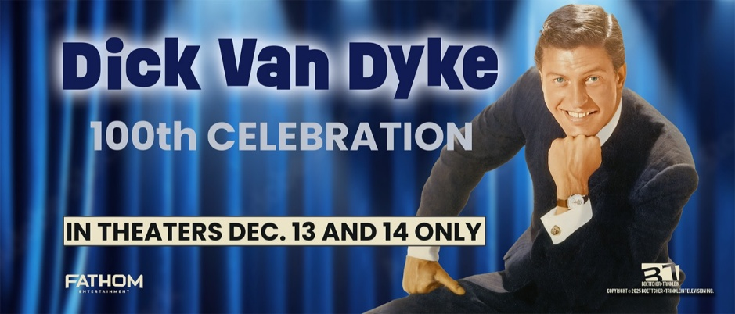
Dick Van Dyke
Biography
Richard Wayne “Dick” Van Dyke (born December 13, 1925) is a legendary American actor, comedian, singer, dancer, and producer whose extraordinary career has spanned more than seven decades. As he celebrates his 100th birthday in 2025, Van Dyke remains one of the most beloved and influential figures in American entertainment.
Born in West Plains, Missouri, to Hazel Victoria (McCord) and Loren Wayne “Cookie” Van Dyke, Van Dyke was raised in Danville, Illinois, alongside his younger brother, Jerry Van Dyke, who would also go on to a successful career in television and comedy. Their Midwestern upbringing shaped both their grounded sensibilities and love of performing.
As a child, Van Dyke spent countless afternoons at Danville’s historic Fischer Theatre, where he fell under the spell of classic Laurel and Hardy films. Their physical comedy and expressive timing left an indelible mark, inspiring him to pursue a life of performance — a dream that would carry him from small-town stages to international stardom.
He began his career in the age of 17 as a radio DJ in Danville, then formed a touring comedy duo and transitioned to television with early appearances on WDSU-TV in New Orleans and The Phil Silvers Show. In 1960, he starred in the original Broadway production of Bye Bye Birdie, earning a Tony Award for Best Featured Actor in a Musical.
Van Dyke became a household name as Rob Petrie on The Dick Van Dyke Show (1961–1966), created by Carl Reiner and co-starring Mary Tyler Moore. The series earned him three Emmy Awards and helped revolutionize television comedy, with Van Dyke’s love for live-audience performance helping to usher in the now-standard multi-camera sitcom format.
On film, he starred in timeless classics such as Bye Bye Birdie (1963), Mary Poppins (1964), and Chitty Chitty Bang Bang (1968), bringing his signature blend of warmth, musicality, and physical comedy to audiences around the world. His screen career also included The Comic (1969), Dick Tracy (1990), Night at the Museum (2006, 2014), and Mary Poppins Returns (2018).
He continued his television success with The New Dick Van Dyke Show (1971–1974), the Emmy-winning variety series Van Dyke and Company (1976), and the long-running mystery hit Diagnosis: Murder (1993–2001), which co-starred his son, Barry Van Dyke.
Van Dyke’s honors include six Emmy Awards, a Tony, a Golden Globe, the Screen Actors Guild Life Achievement Award, a Disney Legend designation (1998), a star on the Hollywood Walk of Fame, and induction into the Television Hall of Fame. In 2020, he received one of the nation's highest arts honors, the Kennedy Center Honors.
Still performing with joy and energy well into his 90s, Dick Van Dyke remains one of America’s most enduring and inspiring entertainers. Dick Van Dyke: 100 Celebration, in theatres December 13 and 14, pays tribute not only to his iconic career but also to the small-town beginnings in Danville, Illinois that helped shape a legend.

###

For more information contact:
Randi Cone Eric Becker
for Dick Van Dyke: 100th Celebration Fathom Entertainment
(917) 744-1528 (303) 638-3469
randi@rconemedia.com ebecker@fathomentertainment.com

