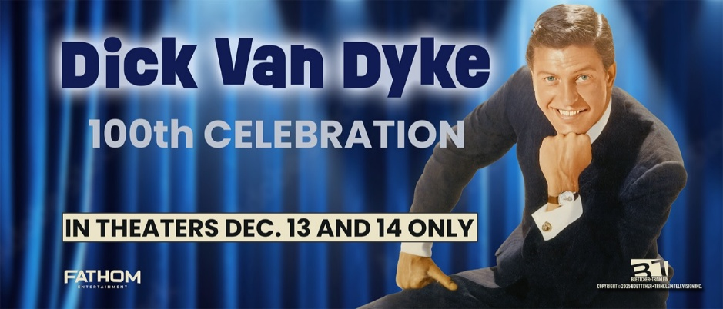

Q&A with Executive Producer and Director Steve Boettcher

Q: Tell us about your film, Dick Van Dyke: 100th Celebration.
A: Dick Van Dyke: 100th Celebration is a joyful, feature-length film event honoring one of the most beloved entertainers of all time. It captures the laughter, music, heart, and timeless magic that define Dick Van Dyke’s extraordinary 80-year career. The film is built entirely in his spirit, full of humor, song, and humanity, pure entertainment from start to finish. We were privileged to sit down with many of the people who worked alongside him over the decades, and to visit his hometown of Danville, Illinois, where his story began. It’s part documentary, part celebration — a big, heartfelt “thank you” to a man who has brought so much happiness to generations.
Q: Why did you want to make this film?
A: This project is truly a gift. I’ve had the privilege of interviewing hundreds of television legends while producing the PBS series Pioneers of Television, and Dick Van Dyke’s name came up constantly — he inspired nearly everyone. Yet there had never been a truly comprehensive, definitive look at his career. As he reached his 100th birthday, it felt like the perfect moment to give something back with this joyful, in-depth tribute to a life and career that helped shape American entertainment. Dick Van Dyke represents everything that’s good about show business: optimism, integrity, and an unshakable belief in the power of joy.
Q: What makes this celebration unique?
A: Dick deserves a big party for his 100th birthday and that’s exactly what we’re giving him. On December 13 and 14, theaters across the country will join together for this special cinematic event. It’s not just a film; it’s an invitation for audiences everywhere to celebrate with him. Fans will experience his career highlights on the big screen from Mary Poppins and The Dick Van Dyke Show to Bye Bye Birdie and Chitty Chitty Bang Bang along with new interviews, unseen clips, and a return to his hometown roots. It’s not just a film; it’s an invitation for everyone to be part of the celebration.

Q: How long has this project been in the making?
A: In many ways, this film has been 30 years in the making. We’ve spent decades interviewing Dick and his friends, colleagues, and co-stars — including Mary Tyler Moore, Carl Reiner, Rose Marie, Betty White, Tim Conway, Chita Rivera, Michele Lee, Derek Hough, and many more. Through these conversations, we’ve assembled a mosaic of his life and legacy from Broadway and Hollywood to his deeply personal return home to Danville. It’s been a true labor of love, capturing the moments and memories that define one of America’s greatest entertainers.
Q: What makes Dick Van Dyke so special as an entertainer?
A: He’s one of the most beloved and enduring entertainers in history — a multi-talented actor, singer, dancer, and comedian whose career has spanned over eight decades. He’s won Emmys, Tonys, and Grammys, but most importantly, he’s won people’s hearts. As Carl Reiner once said, “He’s built with hinges.” Dick’s physicality, grace, timing, and natural sense of play make everything he does feel alive. Wherever he goes, joy follows. He doesn’t just perform, he lifts people up. Incredible things just seem to happen around him.
Q: How would you describe the tone and style of the film?
A: It’s pure Dick Van Dyke — light, musical, funny, heartwarming, and timeless. We wanted the film to feel like him: full of energy, wit, and optimism. On a personal note, I grew up watching The Dick Van Dyke Show. My mom would tell me, “Turn that off and do your homework.” I’d say, “This is my homework.” In a way, this film is the culmination of a lifetime of learning from someone who embodied everything wonderful about performing.
Q: What role does Danville, Illinois play in the story?
A: Danville is where it all began and where it all comes full circle. The film traces Dick’s journey from his Midwestern roots to Broadway and Hollywood, then back home again. We were granted rare, behind-the-scenes access to his return to Danville, including a visit to his old high school nearly eighty years after he first performed there. The students surprised him with a musical tribute, and in true Dick Van Dyke fashion, he joined right in with singing, laughing, and lighting up the room. For me, as a filmmaker, it was a deeply moving experience watching generations connect through pure joy. We also followed Dick on a touching tour of his childhood home, where he reflected on his roots and the values that shaped him long before Hollywood came calling. And here’s a fun detail for fans: his very first performance was at age 17, in a radio drama on WDAN. We found that 1942 recording, and it’s featured in the film.
Q: What can audiences expect from the theatrical event?
A: This is the first time Dick’s extraordinary legacy will be celebrated on the big screen — a once-in-a-lifetime, only-in-theaters event for fans of all ages. Audiences can expect an immersive mix of rare footage, personal stories, and emotional moments from classic TV and film clips to brand-new interviews and an intimate look at his return to Danville. It’s both a cinematic tribute and a shared experience for everyone who’s ever smiled because of Dick Van Dyke.

Q: What do you hope audiences take away from this film? I hope people leave the theater smiling, singing, maybe even dancing a little but most of all, feeling inspired. Dick Van Dyke reminds us that joy, kindness, and creativity never go out of style. He is timeless.

For more information contact:
Randi Cone Eric Becker
for Dick Van Dyke: 100th Celebration Fathom Entertainment
(917) 744-1528 (303) 638-3469
randi@rconemedia.com ebecker@fathomentertainment.com

