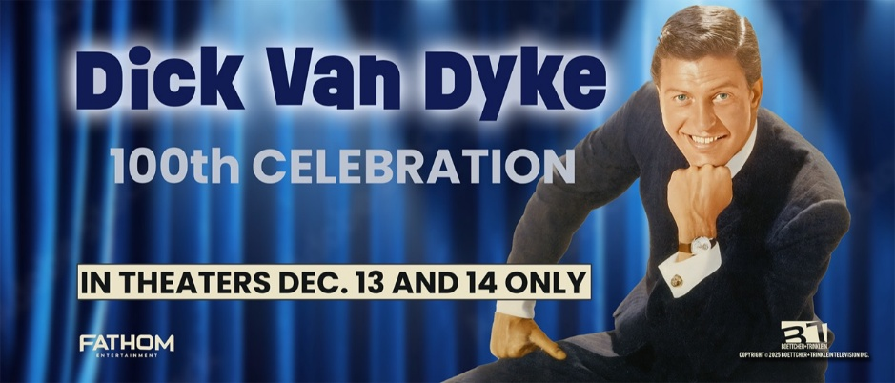
Fact Sheet

LOGLINE:
A joyous feature-length documentary celebrating the legendary Dick Van Dyke’s 100th birthday, featuring iconic film and television moments, intimate interviews with Van Dyke and his friends and co-stars, and a heartwarming journey back to his hometown of Danville, Illinois.
SYNOPSIS:
Celebrating a century of laughter and joy, Dick Van Dyke: 100 Celebration pays tribute to one of America’s most beloved entertainers. This feature-length documentary traces the extraordinary life and career of a true icon showcasing his infectious charm, masterful physical comedy, and enduring talent that has captivated audiences across generations. Featuring unforgettable moments from Bye Bye Birdie, Mary Poppins, Chitty Chitty Bang Bang, The Dick Van Dyke Show, and more, the film includes candid reflections from Van Dyke himself and personal memories from friends and collaborators such as Mary Tyler Moore, Chita Rivera, and Carl Reiner. At the heart of the documentary is Van Dyke’s poignant return to his hometown of Danville, Illinois—a heartfelt journey that shines a light on the community that helped shape a legend.

TICKETS AND INFORMATION: Available HERE
RUNNING TIME: 95 minutes
RELEASE DATES:
A special two-day cinematic engagement only on Mr. Van Dyke’s birthday weekend: December 13 and 14, 2025
DISTRIBUTION: (fathomentertainment.com)
Fathom Entertainment — Nationwide theatrical release
DIRECTOR:
Steve Boettcher
EXECUTIVE PRODUCERS:
Steve Boettcher and Michael Trinklein
PRODUCTION COMPANY (btmedia.us)
Boettcher+Trinklein Television

CAST & PARTICIPANTS:
- Dick Van Dyke
- Mary Tyler Moore
- Carl Reiner
- Chita Rivera
- Michele Lee
- Tim Conway
- Rose Marie
- Morey Amsterdam
- Betty White
- Derek Hough
- Richard Jay-Alexander, Broadway producer/director
- Gino Salomone, veteran entertainment journalist
- Family friends and neighbors from Danville, Illinois

TRAILER: Available HERE

POSTER ART/PRESS IMAGES/ MEDIA KIT: Available HERE

For more information contact:
Randi Cone
for Dick Van Dyke: 100th Celebration
(917) 744-1528
randi@rconemedia.com

Eric Becker
Fathom Entertainment
(303) 638-3469
ebecker@fathomentertainment.com

