
FOR IMMEDIATE RELEASE
Generation-Defining 80’s Movie Pretty in Pink Returns to Theatres Over Valentine’s Day for its 40th Anniversary from Paramount Pictures and Fathom Entertainment
February 13-16
Featuring a Classic 80’s Soundtrack, the Timeless Hit Movie from Writer/Executive Producer John Hughes Romance Comedy Hit Stars Molly Ringwald, Harry Dean Stanton, Jon Cryer, Annie Potts, James Spader and Andrew McCarthy
Includes a “Filmmaker Focus” Bonus Featurette with Director Howard Deutch
Tickets On Sale Now
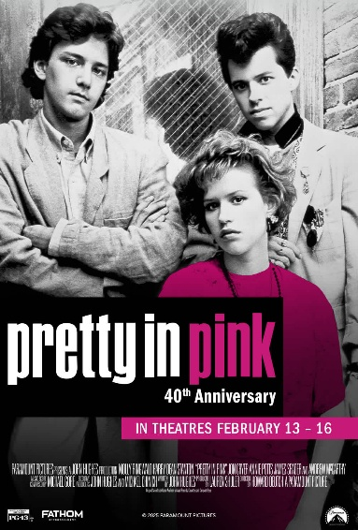

Denver – January 12, 2026 – In celebration of its 40th Anniversary, relive the essential 80s romance comedy Pretty in Pink over this Valentine’s and Galentine’s Day—back on the big screen from Paramount Pictures in partnership with Fathom Entertainment, the leading specialty distributor of content to theatrical partners worldwide.
From its stellar cast lead by Molly Ringwald, Andrew McCarthy, James Spader and Jon Cryer to its memorable 80s soundtrack, audiences nationwide can relive the romance, the heartbreak, and the unforgettable style of this coming-of-age comedy that captured the spirit of an era. This 40th Anniversary showing features a “Filmmaker Focus” bonus featurette with Pretty in Pink Director Howard Deutch recollecting the movie’s production and lasting impact.Tickets are on sale now, for showtimes from February 13–16.
“For Generation X, Pretty in Pink captured the imaginations and hearts of moviegoers, and that legacy lives on today—forty years later—for movie lovers of all ages” said
Ray Nutt, Chief Executive Officer at Fathom Entertainment. “Fathom is thrilled to return the movie to the big screen, newly remastered by Paramount Pictures from a 4K film transfer supervised by director Howard Deutch.”

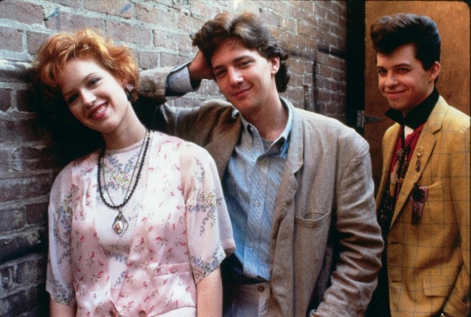
About Pretty in Pink
Teen sensations Molly Ringwald (Sixteen Candles, The Breakfast Club) and Andrew McCarthy (St. Elmo’s Fire) drew rave reviews for their starring performances in this hit love story executive produced and written by John Hughes (Ferris Bueller’s Day Off, Planes, Trains and Automobiles). Andie is a high school girl from the other side of town. Blane’s the wealthy heartthrob who asks her to prom. But as fast as their romance builds, it’s threatened by the painful reality of peer pressure. From its bittersweet story to its hip New Wave soundtrack, the film features great supporting performances from Harry Dean Stanton, Jon Cryer, Annie Potts, and James Spader.
Tickets for Pretty in Pink 40th Anniversary are available now at Fathom Entertainment and participating theatre box offices (theatre locations are subject to change). For more information, visit Fathom Entertainment.
About Fathom Entertainment
Fathom Entertainment is the leading global specialty distributor of content to movie theatres. For more than 20 years, Fathom Entertainment has pioneered theatrical distribution of events and special engagements across various genres and formats, including feature films, episodic content, documentaries, concerts, and live events. Fathom consistently ranks among the top 10 theatrical distributors in North America, and distributes content to cinemas worldwide. Fathom Entertainment is owned by AMC Entertainment Inc. (NYSE: AMC), Cinemark Holdings, Inc. (NYSE: CNK), and Regal Cineworld Group (LSE: CINE.L). For more information, visit FathomEntertainment.com.
###
Contact:
Eric Becker
Fathom Entertainment
(303) 638-3469
ebecker@fathomentertainment.com

