

FOR IMMEDIATE RELEASE

Fathom Entertainment Acquires Caravel Films’
The Apocalypse of St. John for U.S. Theatrical Release February 15-17

The Acclaimed Film Offers a Cinematic Exploration of The Book of Revelation

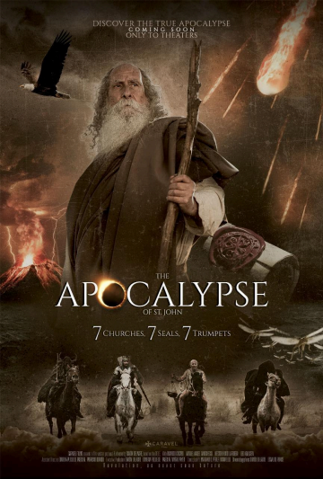

Denver - December 3, 2025 – Fathom Entertainment, the leading specialty distributor of content to theatrical partners worldwide, today announced the acquisition of the highly anticipated docudrama, The Apocalypse of St. John from Caravel Films in Argentina. The Apocalypse is set to hit theatres across the United States February
15-17 in both English-dubbed and Spanish versions. The February 16 showing is exclusively in Spanish.
“The Apocalypse of St. John is a breathtaking visual narrative that will awaken audiences on a topic rarely explored,” said Ray Nutt, Fathom Entertainment Chief Executive Officer. “English and Spanish language audiences of faith will find The Apocalypse of St. John a theatrical engagement worth seeing in theatres this February.”
Written, produced and directed by Simón Delacre, The Apocalypse of St. John masterfully brings to life the complex visions from the Book of Revelation, covering the 7 Churches, 7 Seals and 7 Trumpets. The film provides a visual narrative that not only illuminates the challenging messages of Revelation but also makes them accessible to a wider audience.


Simón Delacre, The Apocalypse of St. John Writer, Producer and Director
“We are so grateful to Fathom Entertainment for believing in this film,” said Simón Delacre, writer, producer and director. “The Apocalypse of St. John is an experience like no other as it takes audiences on an extraordinary journey through the visions seen by the Apostle John. This docudrama takes the audience on an unparalleled cinematic exploration that delves into the deepest secrets of prophecy, guiding them through the mysteries of the Book of Revelation. As the film brings these ancient visions to life, it presents a compelling argument that the Apocalypse is a prophecy soon to be fulfilled.”
This remarkable film has already achieved wide acclaim and has been distributed in over 20-spanish speaking countries including Mexico and Colombia, where it performed on par with major commercial releases. The film also integrates the teachings of Church Fathers and scholars such as Josef Pieper, John Henry Newman, Bartholomew Holzhauser, and Fr. L. Castellani, placing these ideas within a modern context.
The film deeply explores biblical prophecy, offering a unique perspective that spans from the Ascension to the long-awaited Second Coming of Christ. Through a clear and revealing narrative, it allows viewers to better understand past events, interpret the present, and glimpse what is yet to come.
"Prepare for a cinematic experience like no other," said Delacre. "This is not just a film about the end of times, but an exploration of faith, prophecy, and humanity’s deepest questions about the present and the future. Prepare your family, church and community and plan to see Apocalypse next February."
Tickets for The Apocalypse of St. John will be available on January 9 at Fathom Entertainment and participating theatre box offices (theatre locations are subject to change). Fans can sign up now to be among the first notified when tickets go on sale.
More information is also available on the official film website at https://www.apocalypserevealed.com.
For members of the media interested in pre-screening the film or booking interviews, please contact Alexis Walkenstein at AWE PR at walkensteina@gmail.com or
(561) 445-5409.
About Caravel Films
Simón Delacre, is the founder of Caravel Films. He is a devout Catholic and no stranger to the world of filmmaking. With years of experience in science fiction and short film production, Delacre combines his passion for cinema with his deep understanding of the Book of Revelation. His decade-long study of the Apocalypse, guided by the teachings of Early Church Fathers and Catholic scholars, led him to create this masterpiece that blends both edification and entertainment. Delacre, who also contributed significantly to the film’s visual effects and cinematography, believes that cinema can inspire and challenge the viewer to confront both the mysteries of faith and the timeless relevance of biblical prophecy.
About Fathom Entertainment
Fathom Entertainment is the leading global specialty distributor of content to movie
theatres. For more than 20 years, Fathom Entertainment has pioneered theatrical
distribution of events and special engagements across various genres and formats,
including feature films, episodic content, documentaries, concerts, and live events.
Fathom consistently ranks among the top 10 theatrical distributors in North America,
and distributes content to cinemas worldwide. Fathom Entertainment is owned by AMC
Entertainment Inc. (NYSE: AMC), Cinemark Holdings, Inc. (NYSE: CNK), and Regal
Cineworld Group (LSE: CINE.L). For more information, visit FathomEntertainment.com.

###

Contacts:

Alexis Walkenstein Eric Becker
AWE PR for The Apocalypse of St. John Fathom Entertainment
walkensteina@gmail.com ebecker@fathomentertainment.com
(561) 445-5409. (303) 638-3469

