
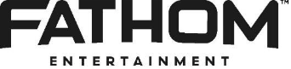
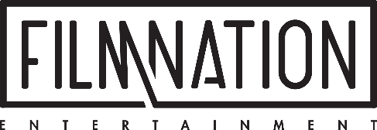

FOR IMMEDIATE RELEASE

LAIKA Partners with Fathom Entertainment
For Domestic Distribution and FilmNation Entertainment
For International Sales on Wildwood

Confirms October 23, 2026 U.S. Release Date

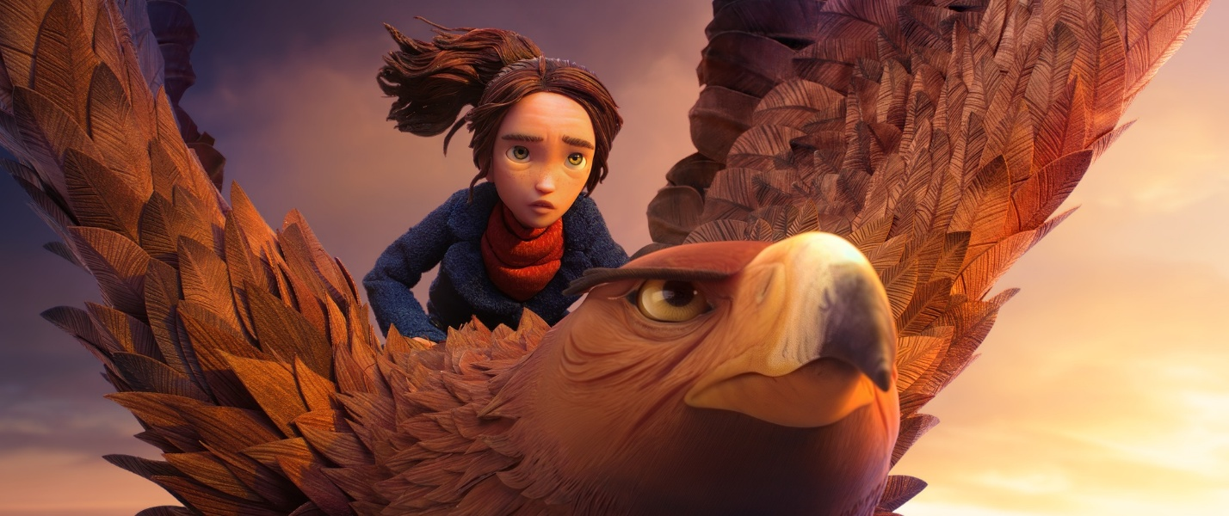

PORTLAND, OR – January 20, 2026 – LAIKA, the studio behind Coraline and ParaNorman, announced today that it has partnered with Fathom Entertainment for
U.S. theatrical distribution and FilmNation Entertainment for international sales on its upcoming stop-motion feature film Wildwood. The film will open in theaters nationwide on October 23, 2026.

The announcement reflects a new phase for LAIKA, as the studio expands its global distribution approach for Wildwood through a combination of independent strategy and best-in-class partners. International sales will launch next month at the European Film Market in Berlin, where FilmNation Entertainment will introduce the film to buyers across international territories.

Wildwood is a handcrafted epic fantasy that transports audiences into a secret, dangerously alive world. A girl’s desperate quest to save her baby brother becomes a high-stakes journey into a forbidden forest filled with enchanted creatures, unlikely allies, and formidable adversaries, where an entire hidden realm hangs in the balance. In an era of automation, LAIKA delivers its most ambitious and globally accessible film yet, combining human-crafted artistry with large-scale cinematic storytelling.
The cast includes Carey Mulligan, Peyton Elizabeth Lee, Jacob Tremblay, Mahershala Ali, Angela Bassett, Awkwafina, Jake Johnson, Charlie Day, Amandla Stenberg, Jemaine Clement, Maya Erskine, Tantoo Cardinal, Tom Waits, and Richard E. Grant.

“Wildwood is a testament to LAIKA walking its own path,” said David Burke, the studio’s Chief Marketing and Operations Officer. “For Wildwood, we’re taking a more customized approach to how we bring the film to audiences, matching partners to the specific needs and ambitions of the project. Partnering with Fathom’s Denver-based team brings national perspective and operational strength to the U.S. release, while working with FilmNation internationally positions the film with scale, reach, and deep expertise in global markets. It’s a strategy built specifically for Wildwood, preserving LAIKA’s independence while aligning with world-class collaborators to support the film’s ambition.”

The partnership with Fathom builds on the success of LAIKA’s recent theatrical re-releases, including the 15th anniversary return of Coraline and a limited engagement of ParaNorman (Remastered). With Coraline earning $56 million worldwide, these performances underscore sustained fan demand to experience LAIKA on the big screen and reflect the studio’s long-view approach to movie-going, creating renewed audience engagement over time by returning its films to theaters, where they were made to be experienced.

“Wildwood is the biggest world LAIKA has ever built, and the most personal,” said Travis Knight, President and Chief Executive Officer of LAIKA and director of Wildwood. “It’s a story about the pull of the unknown, the courage it takes to step into it, and who you become along the way. Our movie is a celebration of artistry over algorithms, and of the belief that films made by hand, with enormous care, can still feel bold, surprising, dangerous, and alive. We designed Wildwood to be seen the way movies first captured our imaginations: discovered in the dark, on a big screen, with a room full of fellow dreamers experiencing joy, silence, and wonder together. Partnering with Fathom and FilmNation means Wildwood will arrive with intention - as a true cinematic event meant to be shared.”

Fathom Entertainment, based in Denver, Colorado, will handle a full theatrical release across the United States. Wildwood will open nationwide on October 23, 2026.

"Wildwood is a magnificently ambitious stop motion film and a landmark achievement in handcrafted cinematic artistry — a project that means so much to both LAIKA and Fathom Entertainment. It’s a breathtaking creative feat that will captivate audiences when it arrives on the big screen this October 23rd,” said Ray Nutt, Chief Executive Officer at Fathom Entertainment. “Fathom is elated to build on our past theatrical re-release successes with LAIKA, including Coraline and ParaNorman, and to be selected and entrusted as the distributor for a full, nationwide U.S. theatrical release of Wildwood consistent with that of the legacy Hollywood studios, complemented by the innovation Fathom brings to all its theatrical engagements. Distributing Wildwood to U.S. theatres further exemplifies Fathom Entertainment’s growth and evolution into a full-service specialty theatrical distributor.”

Tickets for Wildwood in the United States will be available later this summer at Fathom Entertainment and participating theatre box offices (theatre locations are subject to change). Fans can sign up now to be among the first notified when tickets go on sale.

Internationally, LAIKA has partnered with FilmNation Entertainment, a leading independent entertainment company that produces, finances, and distributes films and series with global reach. FilmNation’s recent slate includes Anora and Conclave, with past credits including Promising Young Woman, Arrival, and The Big Sick. FilmNation will represent LAIKA’s Wildwood across international territories, beginning with the European Film Market in Berlin.

“LAIKA is synonymous with originality and imagination and Wildwood is the studio’s most extraordinary film to date,” said Glen Basner, FilmNation CEO & Founder. “LAIKA’s superfans around the world, who most recently enjoyed the fantastic re-release of Coraline and ParaNorman, will be lining up for this new adventure. We are thrilled to introduce Wildwood to international distributors who are ready to join the spectacular world of LAIKA.”

About LAIKA
Founded in 2005 just outside Portland, Oregon, LAIKA has produced five films: Missing Link (2019), Kubo and the Two Strings (2016), The Boxtrolls (2014), ParaNorman (2012) and Coraline (2009). All were nominated for the Academy Award® for Outstanding Animated Feature. Kubo and the Two Strings won the BAFTA® Award for Best Animated Film and received an additional Oscar® nomination for Visual Effects. Missing Link was awarded the Golden Globe® for Best Animated Film. LAIKA was awarded a Scientific and Technology Oscar® in 2016 for its innovation in 3D printing. Among the animated films in development are The Night Gardener, from an original idea by Bill Dubuque, creator of the hit series Ozark, and Piranesi, based on the NYT bestselling novel by Susanna Clarke with a screenplay to be written by Dave Kajganich.

LAIKA’s Live Action subsidiary has a range of projects in development including a feature film based on the action thriller novel Seventeen by screenwriter John Brownlow; the original script Crumble, written and directed by Brian Duffield (Spontaneous) with Phil Lord and Chris Miller (Spider-verse films) producing, and an original project from Oscar®-nominated screenwriter Jon Spaihts (Dune). Captain Marvel filmmakers Anna Boden & Ryan Fleck will write and direct LAIKA’s live action adaptation of #1 New York Times bestselling author Taylor Jenkins Reid’s novel Atmosphere. Lucy Liu and Charles Melton will star in director Lulu Wang’s film version of Katie Kitamura’s bestselling novel Audition, which LAIKA is producing alongside Higher Ground Productions. www.laika.com

About Fathom Entertainment
Fathom Entertainment is the leading global specialty distributor of content to movie theatres. For more than 20 years, Fathom Entertainment has pioneered theatrical distribution of events and special engagements across various genres and formats, including feature films, episodic content, documentaries, concerts, and live events. Fathom consistently ranks among the top 10 theatrical distributors in North America and distributes content to cinemas worldwide. Fathom Entertainment is owned by AMC Entertainment Inc. (NYSE: AMC), Cinemark Holdings, Inc. (NYSE: CNK), and Regal Cineworld Group (LSE: CINE.L). For more information, visit FathomEntertainment.com.
About FilmNation Entertainment
Academy-Award®-winning FilmNation Entertainment is a leading independent entertainment company that produces, finances, and distributes films, TV series, podcasts, and theater productions with global appeal. FilmNation productions include Sean Baker’s Anora, which won five Oscars® including Best Picture and Best Actress for Mikey Madison; Edward Berger’s Academy Award®-Winning Conclave, and sales for Pablo Larraín’s Oscar®-nominated Maria, Mike Flanagan’s The Life of Chuck and Derek Cianfrance’s Roofman. The company also produced award-winning box office hits Promising Young Woman, Arrival, and The Big Sick, and is the home of Infrared, a film production label focused on genre films with franchise potential, such as Novocaine.
FilmNation debuted the Emmy Award®-winning TV series I Know This Much is True for HBO. TV releases also include the upcoming Prime Video Original Series The House of the Spirits, the historical epic Black Gold for NDR and ARD and Small Town, Big Story for Sky. The company’s popular podcasts champion non-fiction storytelling and include the Signal Award-Winning SNAFU with Ed Helms and the podcast-inspired book SNAFU: The Definitive Guide to History’s Greatest Screwups is a New York Times Best Seller. FilmNation’s theater credits include 2024 Best Play Tony-Winner Stereophonic, and the Tony Award-Winning productions Prima Facie, The Sound Inside, and The Band’s Visit.
###

Press Contacts:
LAIKA
Maggie Begley
maggie@mbcprinc.com; 310.749.3055

Fathom Entertainment
Eric Becker
ebecker@fathomentertainment.com; 303.638.3469

FilmNation Entertainment
Emma Kelly
ekelly@filmnation.com; 917.224.6515

