

FOR IMMEDIATE RELEASE

“Remember, Remember the Fifth of November,”
V for Vendetta Returns to the Big Screen in 2026
For Its 20th Anniversary

Fathom Entertainment, Saga Arts, and Warner Bros. Motion Picture Group Announce Nationwide Theatrical Release on November 1 and 5, 2026
Special Teaser Trailer Invites Audiences to “Join V One Year from Tonight”

Sign Up at FathomEntertainment.com to Be Notified When Tickets Go On Sale

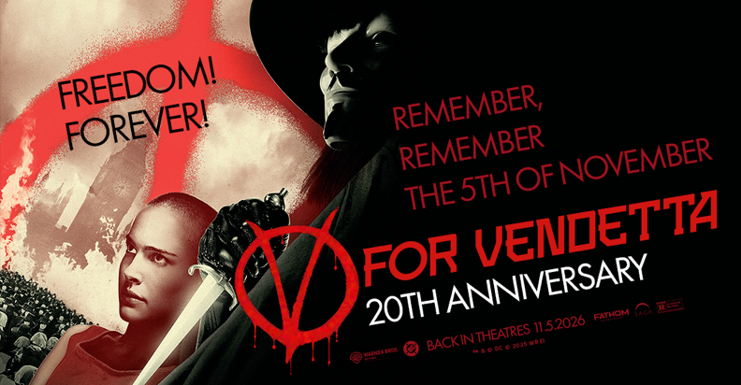

Denver – November 5, 2025 – Freedom! Forever! Justice returns to the big screen one year from tonight. Fathom Entertainment, the leading specialty distributor of event cinema worldwide, Saga Arts, and Warner Bros. Motion Picture Group today announced the 20th Anniversary of V for Vendetta will arrive in theatres nationwide on November 1 and 5, 2026.

Audiences can view the teaser trailer featuring V’s iconic invitation to “join him one year from tonight” en masse to celebrate the revolutionary spirit and enduring legacy of one of the most powerful political action thrillers of the 21st century.

Based on the groundbreaking graphic novel and produced by the Wachowskis, V for Vendetta (2006) became an instant classic, inspiring a generation with its message of defiance and freedom. Set against the futuristic landscape of totalitarian Britain, V for Vendetta tells the story of a young working-class woman named Evey, played by Natalie Portman, who is rescued from a life-and-death situation by a masked man known only as “V,” played by Hugo Weaving.

“From its early days as a graphic novel and then a feature film, few properties have struck a chord with fans and been more thought-provoking societally than V for Vendetta,” said Tom Lucas, Vice President of Studio Relations at Fathom Entertainment. “Twenty years later, the movie still resonates, and Fathom is so pleased to bring it back to theatres next November with our partners at Warner Bros. and Saga Arts.”

Fans can sign up now at Fathom Entertainment to be among the first notified when tickets go on sale in 2026 for the V for Vendetta 20th Anniversary celebration.

About V for Vendetta
Warner Bros. Pictures presents, in association with Virtual Studios, a Silver Pictures production in association with Anarchos Productions Inc., Natalie Portman in V for Vendetta, starring Hugo Weaving, Stephen Rea and John Hurt. Directed by James McTeigue, the film is produced by Joel Silver, Grant Hill and The Wachowskis from a screenplay by The Wachowskis, based on the graphic novel illustrated by David Lloyd and published by Vertigo/DC Comics. The executive producer is Benjamin Waisbren. The director of photography is Adrian Biddle, B.S.C.; the production designer is Owen Paterson; the editor is Martin Walsh, A.C.E.; and the music is composed by Dario Marianelli. V for Vendetta is a United Kingdom-Germany co-production. This film has been rated “R” by the MPAA for “strong violence and some language.” V for Vendetta is distributed by Warner Bros. Pictures, a Warner Bros. Entertainment Company.

About Fathom Entertainment
Fathom Entertainment is the leading global specialty distributor of content to movie theatres. For more than 20 years, Fathom Entertainment has pioneered theatrical distribution of events and special engagements across various genres and formats, including feature films, episodic content, documentaries, concerts, and live events. Fathom consistently ranks among the top 10 theatrical distributors in North America and distributes content to cinemas worldwide. Fathom Entertainment is owned by AMC Entertainment Inc. (NYSE: AMC), Cinemark Holdings, Inc. (NYSE: CNK), and Regal Cineworld Group (LSE: CINE.L). For more information, visit FathomEntertainment.com.

Contacts:

Eric Becker
Fathom Entertainment
ebecker@fathomentertainment.com
(303) 638-3469

Rob Miller
Saga Arts
rob@sagaarts.com
(702) 375-5396

