

MEDIA ALERT — January 30, 2026 –– FOR IMMEDIATE RELEASE

Go Ninja Go! Turtlemania Returns!
TEENAGE MUTANT NINJA TURTLES II: THE SECRET OF THE OOZE 35th Anniversary Hits Theaters Nationwide for One Full Week — March 13 - 19
Tickets On Sale Now for the First-Ever Theatrical 4K Presentation Featuring an Exclusive, Never-Before-Seen Kevin Eastman Featurette Revealed in a Brand New Trailer Released Today from Fathom Entertainment, Saga Arts, and Warner Bros.

Tickets Available for Purchase Now at FathomEntertainment.com
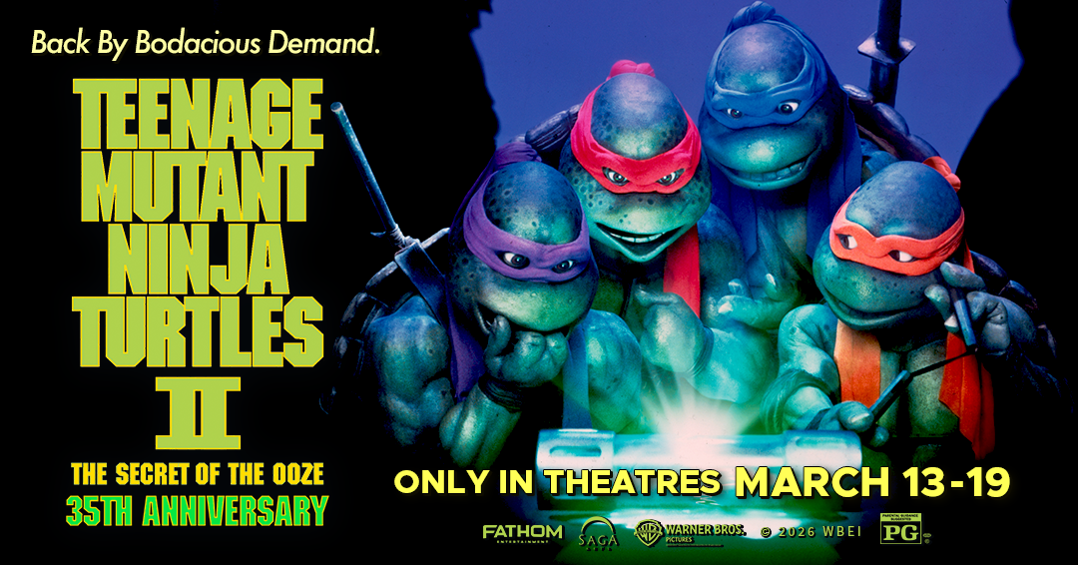

WHAT: Fathom Entertainment, the leading specialty distributor of content to theatrical partners worldwide, Saga Arts, and Warner Bros. Motion Picture Group announce that tickets are now on sale for the 35th Anniversary theatrical re-release of Teenage Mutant Ninja Turtles II: The Secret of the Ooze, returning to theaters nationwide for one full week, March 13–19.

Back by bodacious demand & for the first time ever, Teenage Mutant Ninja Turtles II: The Secret of the Ooze will be presented in theaters in a newly restored 4K presentation, giving longtime fans and first-time audiences the chance to experience the sequel together with unprecedented clarity and scale on the big screen.

Following the massive success of last year’s Teenage Mutant Ninja Turtles 35th Anniversary event, which expanded from an initial two-day engagement to four weeks in theaters, reached the Top 10 at the box office, and drew over 280,000 attendees nationwide, Turtlemania is back once again for families, longtime fans, and a new generation discovering the Turtles together in theaters.

The ticket on-sale announcement arrives alongside a brand new trailer released today, giving fans their first look at the nationwide celebration and the return of one of the most beloved sequels of the franchise.

In addition to the feature presentation, the anniversary event will include a never-before-seen featurette, The Ninja Turtles: Revolutions, appearing before the movie—step into the mind of TMNT co-creator Kevin Eastman, joining him on a vision through the past. Sit down alongside the icon at his personal drawing desk while he illustrates through the revolving history and mythos of the Teenage Mutant Ninja Turtles legend.

WHO: Fathom Entertainment, Saga Arts, and Warner Bros. Motion Picture Group
WHEN: Friday, March 13 through Thursday, March 19 (check you local theatre for specific showtimes
WHERE: Tickets for Teenage Mutant Ninja Turtles II: The Secret of the Ooze 35th Anniversary may be purchased at Fathom Entertainment or at participating theatre box offices (theatre locations are subject to change).
MEDIA PASSES: Media passes are available on a limited basis to qualifying members of the press at participating theatre locations

ASSETS: For artwork/photos, visit the Fathom Entertainment press site.

###
Contacts:
Eric Becker Rob Miller
Fathom Entertainment Saga Arts
ebecker@fathomentertainment.com rob@sagaarts.com
(303) 638-3469 (702) 375-5396

