

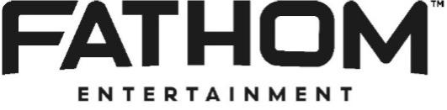

FOR IMMEDIATE RELEASE

Utopia and Fathom Entertainment Team Up
for RAD Day 2026 40TH Anniversary Celebration

Remastered in 4K, Audiences are Stoked for the Annual Event; Expanded to
Two Days on March 22 and 24 Due to Popular Demand
The Event Will Feature a Sneak Peek of Effortless: The Eddie Fiola Story Which Offers a Rare View From Behind the Handlebars of the Legendary Stunt Man Eddie Fiola - Diving Into His Life and Legacy

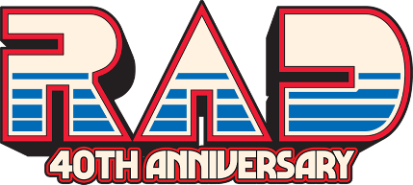

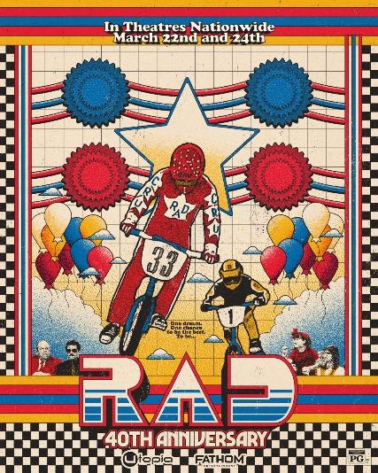

Los Angeles and Denver - February 20, 2026 - For the fifth year in a row, Utopia and Fathom Entertainment, the leading specialty distributor of content to theatrical partners worldwide, are teaming up to bring the 2026 RAD Day celebration to over 700 theatres across the United States. In response to strong fan enthusiasm and anticipated audience demand, the 40th anniversary event will expand to a two-day theatrical schedule on March 22 and 24.

VIEW TRAILER HERE

Originally released on March 21, 1986, the beloved annual RAD Day tradition prepares for its 40th anniversary celebration. Remastered in 4K, the cult classic film stars Bill Allen (Cru Jones), Lori Loughlin (Christian Hollings), Talia Shire (Mrs. Jones), Jack Weston (Duke Best), Ray Walston (Burton Timmer), and 1984 Olympic gymnastics champion Bart Connor (Bart Taylor). Directed by Hal Needham, RAD tells the story of Cru (Allen), a young man with a dream of making it big as a BMX racer by racing the “Helltrack” and winning the grand prize of $100,000 and a Corvette.

"RAD turning 40 and heading back to theaters nationwide? What more can I say besides... it's gonna be RAD,” said Utopia’s Head of Marketing & Distribution, Kyle Greenberg. “So, now that it's official, remember there's always room for one more on the RAD racing team for another victory lap with the cult classic that never stopped racing"

“RAD Day has grown into a true cultural moment for fans of the legendary ’80s BMX classic, driven by the passion of its audience and our ongoing collaboration with Utopia,” said Shannah Miller, VP of Marketing, Fathom Entertainment. “As Fathom celebrates the film’s 40th anniversary, we are very pleased to expand this RADDEST celebration into a two-day theatrical event that brings fans together at the cinema and puts RAD back once again on the big screen.”

For the 40th anniversary screenings, RAD fans will enjoy an exclusive sneak peek of the forthcoming documentary Effortless: The Eddie Fiola Story - following BMX legend and Hollywood stuntman Eddie Fiola's career, personal life, and pursuit of making it to the top in his sport and second career as an elite stuntman on some of the biggest budget movies in Hollywood. The film features interviews with Eddie Fiola, Tony Hawk, Ed Helms, Steve Caballero, Christian Hosoi, Ryan Nyquist, Martin Aparijo, Larry Edgar and Gale Webb and is written and directed by Billy Henrickle.

Tickets for RAD 40th Anniversary are available now at Fathom Entertainment and participating theatre box offices (theatre locations subject to change).

About Utopia
Utopia is a New York and Los Angeles based film distribution and sales company. Focused on showcasing truly independent features and documentaries while supporting the next wave of filmmakers and audience discovery, recent Utopia releases include Pascal Plante's breakout horror Red Rooms, Sean Price Williams’ acclaimed debut feature The Sweet East, Ally Pankiw’s comedy I Used To Be Funny starring Rachel Sennott, Ali Abbasi’s Oscar shortlisted and Cannes winner Holy Spider. Other Utopia releases include the cult-BMX classic and event-theatrical hit Rad; Sundance breakout and Gotham Awards-nominated We're All Going to the World's Fair by Jane Schoenbrun; Gaspar Noe's Cannes-lauded Vortex starring Dario Argento; the Indie Spirit winner Shiva Baby by Emma Seligman and more. Utopia has also launched its Originals division, dedicated to developing, packaging and producing original features and episodic projects including Gia Coppola’s The Last Showgirl.

About Fathom Entertainment
Fathom Entertainment is the leading global specialty distributor of content to movie theatres. For more than 20 years, Fathom Entertainment has pioneered theatrical distribution of events and special engagements across various genres and formats, including feature films, episodic content, documentaries, concerts, and live events. Fathom consistently ranks among the top 10 theatrical distributors in North America and distributes content to cinemas worldwide. Fathom Entertainment is owned by AMC Entertainment Inc. (NYSE: AMC), Cinemark Holdings, Inc. (NYSE: CNK), and Regal Cineworld Group (LSE: CINE.L). For more information, visit FathomEntertaiment.com.

###

Contacts:

Sylvia Desrochers Sammantha Snowden
42West for Utopia Fathom Entertainment
radday@42west.com ssnowden@fathomentertainment.com

